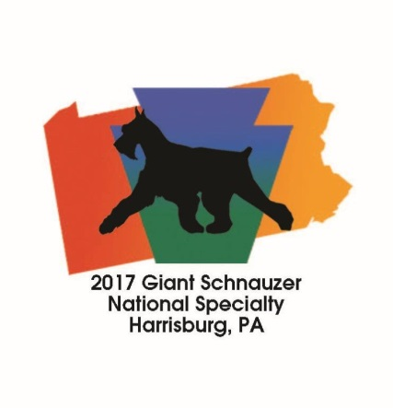
GSCA National Specialty Reservation Form
Must be postmarked no later than 7/26/2017

Name: ____________________________________________
Address: ____________________________________________
____________________________________________
____________________________________________
Phone: _________________________
Email: ____________________________________________
Event | Quantity | Price | Total
Awards Banquet |  | $45 PerPerson
CGC Test |  | $25 PerDog
Seminar - Movement & Fitness Exercises for the Conformation Dog by Chris Zink |  | $70 PerPerson
General Donation
Please make funds payable to GSCA.
Print and Mail this form with check/money order to :
Marina Raukhverger
17915 Bunker Hill Road
Parkton, MD 21120

